1. **Admin interface design**
   1. **Admin/Staff – Login**

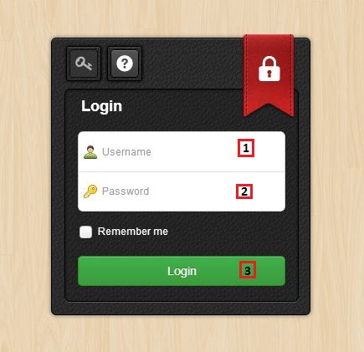

**Fields**

|  |  |  |  |  |  |  |  |
| --- | --- | --- | --- | --- | --- | --- | --- |
| **No** | **Field name** | **Description** | **Read only** | **Manda-tory** | **Control type** | **Data type** | **Length** |
| 1 | Username | Fill username | No | Yes | Textbox | String | [6-20] |
| 2 | Password | Fill password | No | Yes | Password | String | [6-20]] |

**Button/Hyperlink**

|  |  |  |  |  |
| --- | --- | --- | --- | --- |
| **No** | **Function** | **Description** | **Validation** | **Outcome** |
| 2 | Login | Click to login into the system | Yes | Transfer to Admin/Staff Home page |

* 1. **Admin – Manage user**

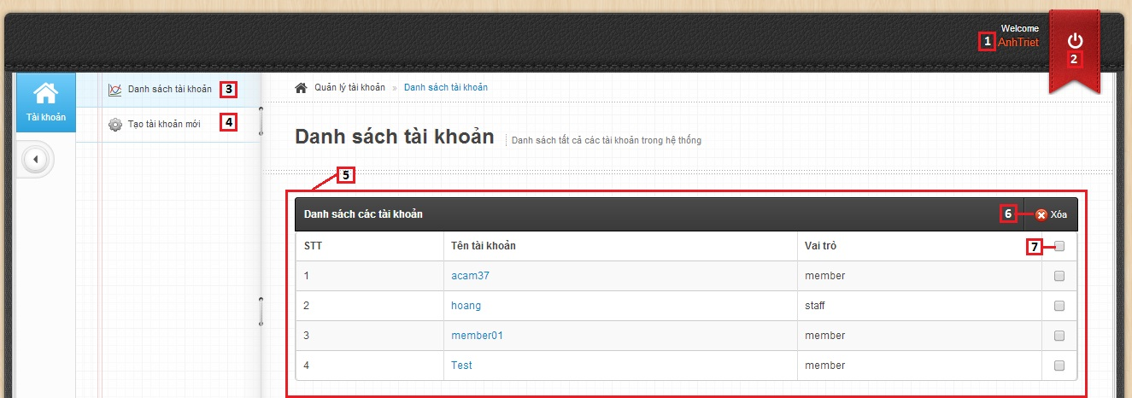

**Fields**

|  |  |  |  |  |  |  |  |
| --- | --- | --- | --- | --- | --- | --- | --- |
| **No** | **Field name** | **Description** | **Read only** | **Manda-tory** | **Control type** | **Data type** | **Length** |
| 1 | Account info | Username of admin | Yes | Yes | Textview | N/A | N/A |
| 5 | User list | Table showing | Yes | Yes | Table | N/A | N/A |
| 7 | Select user | Select user to delete | No | No | Check box | N/A | N/A |

**Button/Hyperlink**

|  |  |  |  |  |
| --- | --- | --- | --- | --- |
| **No** | **Function** | **Description** | **Validation** | **Outcome** |
| 2 | Logout | Click to logout account | No | Transfer to Admin/Staff Login page |
| 3 | Manage user account | Click to go to manage user page | No | Transfer to Manage user page |
| 4 | Create new account | Click to go to create new user page | No | Transfer to Create new user page |
| 6 | Delete user | Click to delete the user that selected | No | Message completed |

**Table User List includes**

|  |  |  |  |  |  |
| --- | --- | --- | --- | --- | --- |
| **Field name** | **Description** | **Read only** | **Control type** | **Data type** | **Length** |
| No. | Number | Yes | Textview | Integer | N/A |
| Username | Username | Yes | Textview | String | N/A |
| Role | Role of user | Yes | Textview | String | N/A |
| Checkbox field | Select user | No | Checkbox | N/A | N/A |

* 1. **Admin – Create new user**

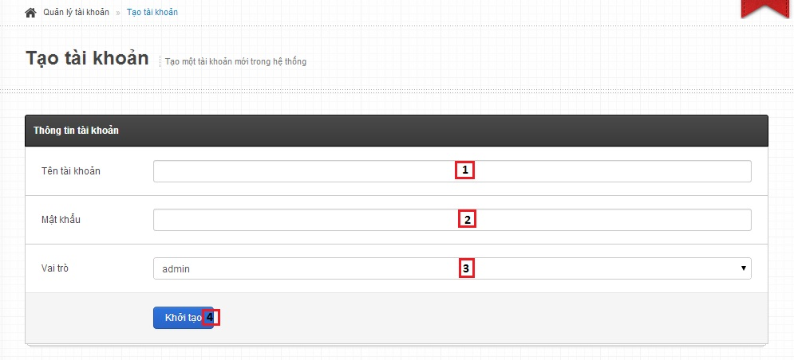

**Fields**

|  |  |  |  |  |  |  |  |
| --- | --- | --- | --- | --- | --- | --- | --- |
| **No** | **Field name** | **Description** | **Read only** | **Manda-tory** | **Control type** | **Data type** | **Length** |
| 1 | Username | Fill username of user | No | Yes | Textbox | String | [6-20] |
| 2 | Password | Fill password | No | Yes | Password | String | [6-20] |
| 3 | Role | Select role of user | No | Yes | Drop down list | N/A | N/A |

**Button/Hyperlink**

|  |  |  |  |  |
| --- | --- | --- | --- | --- |
| **No** | **Function** | **Description** | **Validation** | **Outcome** |
| 4 | Create new user | Create new user | Yes | Transfer to Manage user page |

1. **Staff interface design**
   1. **Staff – Training data page**

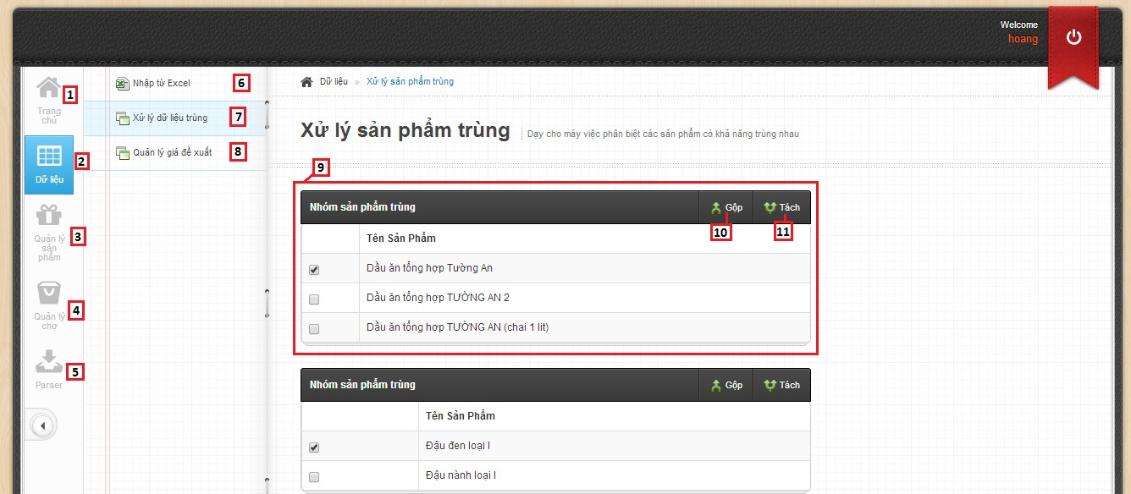

**Fields**

|  |  |  |  |  |  |  |  |
| --- | --- | --- | --- | --- | --- | --- | --- |
| **No** | **Field name** | **Description** | **Read only** | **Manda-tory** | **Control type** | **Data type** | **Length** |
| 1 | Home page | Home page | Yes | Yes | Textview | N/A | N/A |
| 2 | Data | Data | Yes | Yes | Textview | N/A | N/A |
| 3 | Manage product | Manage product | Yes | Yes | Textview | N/A | N/A |
| 4 | Manage market | Manage market | Yes | Yes | Textview | N/A | N/A |
| 5 | Parser | Manage parse data | Yes | Yes | Textview | N/A | N/A |
| 9 | Data training list | Table showing | Yes | Yes | Textview | N/A | N/A |

**Button/Hyperlink**

|  |  |  |  |  |
| --- | --- | --- | --- | --- |
| **No** | **Function** | **Description** | **Validation** | **Outcome** |
| 6 | Import excel | Click to go to import excel page | No | Transfer to Import excel page |
| 7 | Training match | Click to go to training match page | No | Transfer to Training match page |
| 8 | Manage propose price | Click to go to manage propose price page | No | Transfer to Manage propose price page |
| 10 | Merge | Click to merge product | Yes | N/A |
| 11 | Split | Click to split product | Yes | N/A |

**Table data training List includes**

|  |  |  |  |  |  |
| --- | --- | --- | --- | --- | --- |
| **Field name** | **Description** | **Read only** | **Control type** | **Data type** | **Length** |
| Checkbox field | Select product | No | Checkbox | N/A | N/A |
| Product name | Product name | Yes | Textview | String | N/A |

* 1. **Staff – Import excel page**
     1. **Import excel – Correct product list**

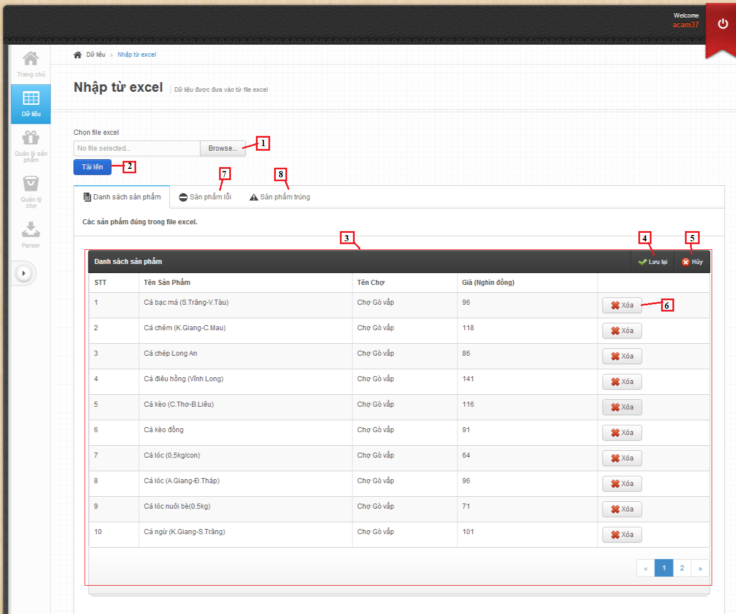

**Fields**

|  |  |  |  |  |  |  |  |
| --- | --- | --- | --- | --- | --- | --- | --- |
| **No** | **Field Name** | **Description** | **Read only** | **Mandatory** | **Control Type** | **Data Type** | **Length** |
| 3 | Product list | Show list product | No | No | Table list view | N/A | N/A |

**Button/ Hyperlink**

|  |  |  |  |  |
| --- | --- | --- | --- | --- |
| **No** | **Function** | **Description** | **Validation** | **Outcome** |
| 1 | Select excel file | Click to select excel file | N/A | N/A |
| 2 | Upload excel file | Get data in excel file | N/A | N/A |
| 4 | Save product | Click to save product into database | N/A | Show message result. |
| 5 | Cancel import | Click to cancel import product | N/A | N/A |
| 6 | Remove product | Click to remove product | N/A | N/A |
| 7 | Error product list | Click to transfer to error product list | N/A | Transfer to error product tab |
| 8 | Duplicate product list | Click to transfer to duplicate product list | N/A | Transfer to duplicate product tab |

**Product List includes**

|  |  |  |  |  |  |
| --- | --- | --- | --- | --- | --- |
| **Field Name** | **Description** | **Read only** | **Control Type** | **Data Type** | **Length** |
| Number row | Number of row | Yes | Textview | String | N/A |
| Product name | Show product name | Yes | Textview | String | N/A |
| Market name | Show market name | Yes | Textview | String | N/A |
| Price | Show product price | Yes | Textview | Integer | N/A |
| Action | Action for product | No | Button | N/A | N/A |

* + 1. **Import excel – Error product list**

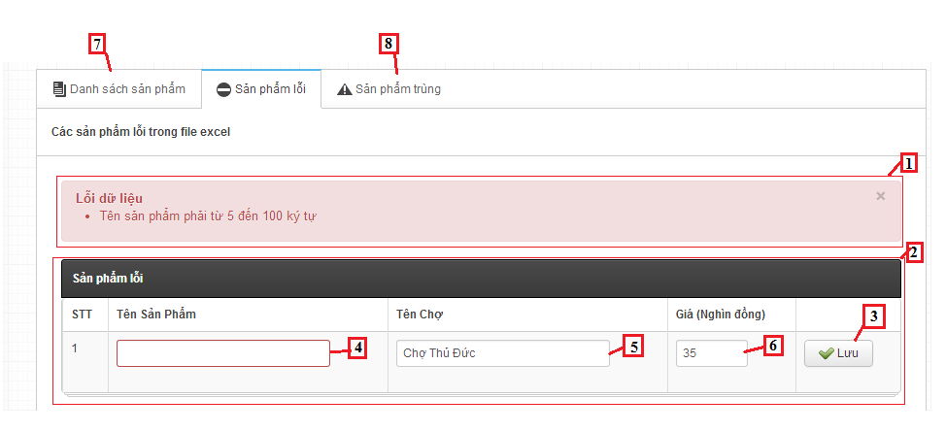

**Fields**

|  |  |  |  |  |  |  |  |
| --- | --- | --- | --- | --- | --- | --- | --- |
| **No** | **Field Name** | **Description** | **Read only** | **Mandatory** | **Control Type** | **Data Type** | **Length** |
| 1 | Message | Show error message | Yes | N/A | Textview | String | N/A |
| 2 | Error Product list | Show list product | No | No | Table list view | N/A | N/A |
| 4 | Product name | Fill name of product | No | Yes | Textbox | String | [6-100] |
| 5 | Market name | Fill name of market | No | Yes | Textbox | String | [6-100] |
| 6 | Price | Fill price of product | No | Yes | Textbox | String | [1-10000] |

**Button/ Hyperlink**

|  |  |  |  |  |
| --- | --- | --- | --- | --- |
| **No** | **Function** | **Description** | **Validation** | **Outcome** |
| 3 | Save product | Click to save product | N/A | N/A |
| 7 | Correct product list | Click to transfer to correct product list | N/A | Transfer to correct product tab |
| 8 | Duplicate product list | Click to transfer to duplicate product list | N/A | Transfer to duplicate product tab |

**Error Product List includes**

|  |  |  |  |  |  |
| --- | --- | --- | --- | --- | --- |
| **Field Name** | **Description** | **Read only** | **Control Type** | **Data Type** | **Length** |
| Number row | Number of row | Yes | Textview | String | N/A |
| Product name | Show product name | Yes | Textview | String | N/A |
| Market name | Show market name | Yes | Textview | String | N/A |
| Price | Show product price | Yes | Textview | Integer | N/A |
| Action | Action for product | No | Button | N/A | N/A |

* + 1. **Import excel – Duplicate product list**

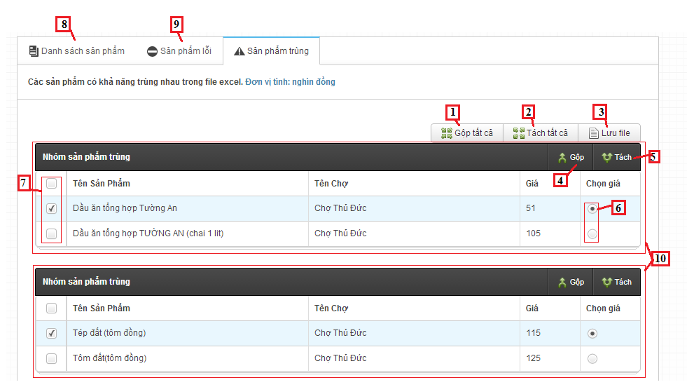

**Fields**

|  |  |  |  |  |  |  |  |
| --- | --- | --- | --- | --- | --- | --- | --- |
| **No** | **Field Name** | **Description** | **Read only** | **Mandatory** | **Control Type** | **Data Type** | **Length** |
| 10 | Duplicate product table | Show duplicate product | N/A | N/A | Table list view | N/A | N/A |

**Button/ Hyperlink**

|  |  |  |  |  |
| --- | --- | --- | --- | --- |
| **No** | **Function** | **Description** | **Validation** | **Outcome** |
| 1 | Join all product | Click to join products in each table | N/A | N/A |
| 2 | Divide all product | Click to divide product in each table | N/A | N/A |
| 3 | Save log file | Click to save duplicate product to text file | N/A | Show message result |
| 4 | Join product | Click to join products in current table | N/A | N/A |
| 5 | Divide product | Click to divide product in current table | N/A | N/A |
| 6 | Price | Select price of product | N/A | N/A |
| 7 | Checkbox product | Click to select product | N/A | N/A |
| 8 | Correct product list | Click to transfer to correct product list | N/A | Transfer to correct product tab |
| 9 | Duplicate product list | Click to transfer to duplicate product list | N/A | Transfer to duplicate product tab |

**Duplicate Product List includes**

|  |  |  |  |  |  |
| --- | --- | --- | --- | --- | --- |
| **Field Name** | **Description** | **Read only** | **Control Type** | **Data Type** | **Length** |
| Checkbox | Checkbox of product | N/A | Checkbox | Checkbox | N/A |
| Product name | Show product name | Yes | Textview | String | N/A |
| Market name | Show market name | Yes | Textview | String | N/A |
| Price | Show product price | Yes | Textview | Integer | N/A |
| Select price | Action for product | N/A | Radio | radio | N/A |

* 1. **Staff – Manage propose price page**

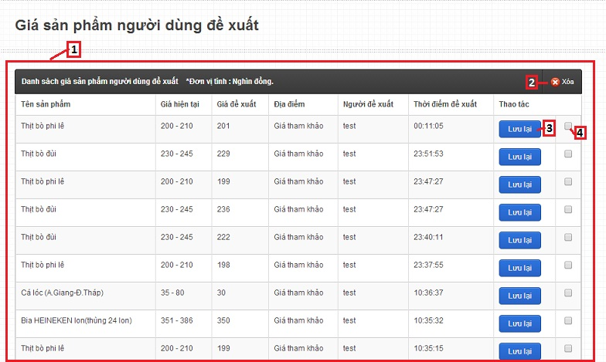

**Fields**

|  |  |  |  |  |  |  |  |
| --- | --- | --- | --- | --- | --- | --- | --- |
| **No** | **Field name** | **Description** | **Read only** | **Manda-tory** | **Control type** | **Data type** | **Length** |
| 1 | User price list | Table showing | Yes | Yes | Table | N/A | N/A |
| 4 | Select product | Select user price to delete | No | No | Check box | N/A | N/A |

**Button/Hyperlink**

|  |  |  |  |  |
| --- | --- | --- | --- | --- |
| **No** | **Function** | **Description** | **Validation** | **Outcome** |
| 2 | Delete user price | Click to delete the user price that selected | No | Message completed |
| 3 | Save user price | Click to update product price | No | Message completed |

**Table User price List includes**

|  |  |  |  |  |  |
| --- | --- | --- | --- | --- | --- |
| **Field name** | **Description** | **Read only** | **Control type** | **Data type** | **Length** |
| Product name | Product name | Yes | Textview | String | N/A |
| Current price | Product price | Yes | Textview | Integer | N/A |
| Propose price | Propose price | Yes | Textview | Integer | N/A |
| Market name | Market name | Yes | Textview | String | N/A |
| Username | Name of user proposed | Yes | Textview | String | N/A |
| Time proposed | Time proposed | Yes | Textview | DateTime | N/A |
| Action | Action of staff | No | Button, Checkbox | N/A | N/A |

* 1. **Staff – Configure System**

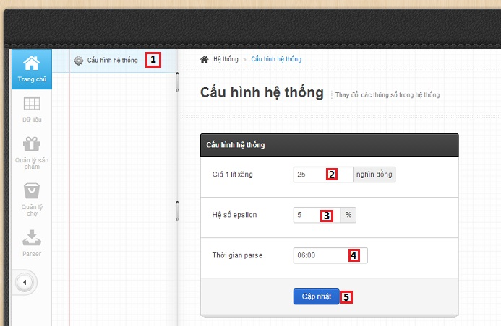

**Fields**

|  |  |  |  |  |  |  |  |
| --- | --- | --- | --- | --- | --- | --- | --- |
| **No** | **Field name** | **Description** | **Read only** | **Manda-tory** | **Control type** | **Data type** | **Length** |
| 2 | Petrol price | Fill petrol price | No | Yes | Textbox | Integer | N/A |
| 3 | Epsilon | Fill epsilon | No | Yes | Textbox | Integer | [0-100] |
| 4 | Time parse | Fill time parse | No | Yes | Time picker | Date Time | N/A |

**Button/Hyperlink**

|  |  |  |  |  |
| --- | --- | --- | --- | --- |
| **No** | **Function** | **Description** | **Validation** | **Outcome** |
| 1 | Configure system | Click to go to configure system page | No | Transfer to configure system page |
| 5 | Update configuration | Click to update configuration system | Yes | Message completed |

* 1. **Staff – Manage Product**

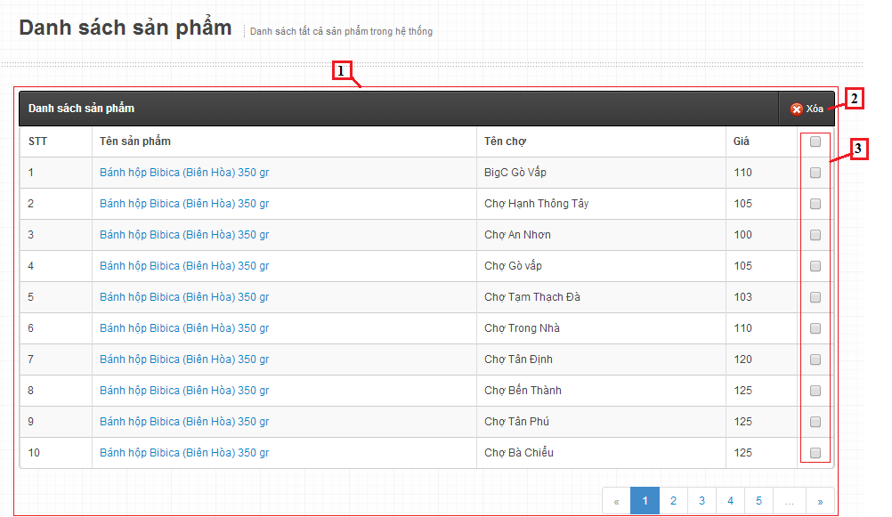

**Fields**

|  |  |  |  |  |  |  |  |
| --- | --- | --- | --- | --- | --- | --- | --- |
| **No** | **Field Name** | **Description** | **Read only** | **Mandatory** | **Control Type** | **Data Type** | **Length** |
| 1 | product table | Show product | N/A | N/A | Table list view | N/A | N/A |

**Button/ Hyperlink**

|  |  |  |  |  |
| --- | --- | --- | --- | --- |
| **No** | **Function** | **Description** | **Validation** | **Outcome** |
| 2 | Delete Product | Click to delete product | N/A | N/A |
| 3 | Checkbox product | Click to select product | N/A | N/A |

**Product List includes**

|  |  |  |  |  |  |
| --- | --- | --- | --- | --- | --- |
| **Field Name** | **Description** | **Read only** | **Control Type** | **Data Type** | **Length** |
| Number row | Number of row | Yes | Textview | String | N/A |
| Product name | Show product name | Yes | Textview | String | N/A |
| Market name | Show market name | Yes | Textview | String | N/A |
| Price | Show product price | Yes | Textview | Integer | N/A |
| Checkbox | Checkbox of product | N/A | Checkbox | Checkbox | N/A |

* 1. **Staff – Create new product**

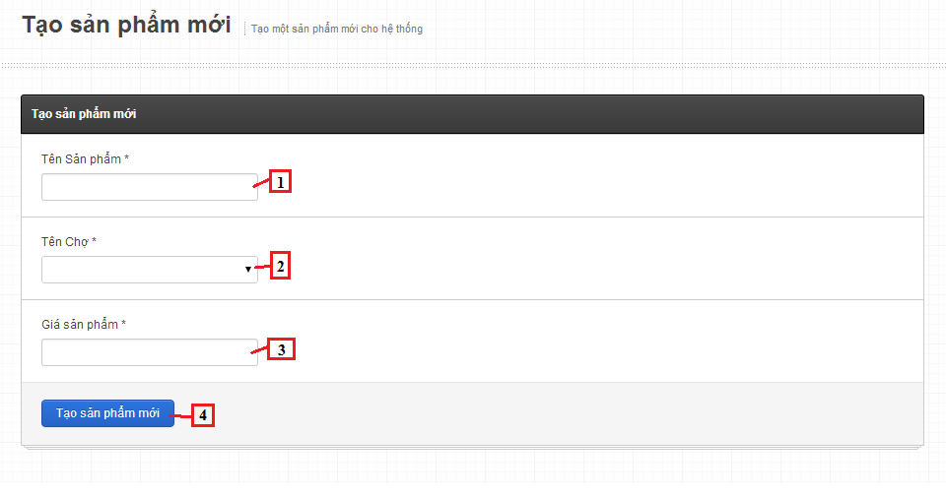

**Fields**

|  |  |  |  |  |  |  |  |
| --- | --- | --- | --- | --- | --- | --- | --- |
| **No** | **Field Name** | **Description** | **Read only** | **Mandatory** | **Control Type** | **Data Type** | **Length** |
| 1 | Product name | Fill name of product | No | Yes | Textbox | String | [6-100] |
| 2 | Market name | Fill name of market | No | Yes | Dropdown list | String | N/A |
| 3 | Price | Fill price of product | No | Yes | Textbox | Integer | [1-10000] |

**Button/ Hyperlink**

|  |  |  |  |  |
| --- | --- | --- | --- | --- |
| **No** | **Function** | **Description** | **Validation** | **Outcome** |
| 4 | Save product | Click to save product into database | Yes | Transfer to manage product pages. |

* 1. **Staff – Manage market**

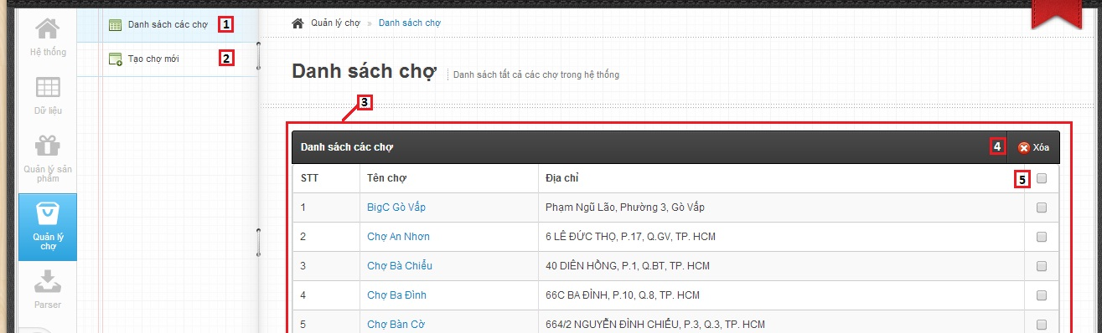

**Fields**

|  |  |  |  |  |  |  |  |
| --- | --- | --- | --- | --- | --- | --- | --- |
| **No** | **Field name** | **Description** | **Read only** | **Manda-tory** | **Control type** | **Data type** | **Length** |
| 3 | Markets list | Table showing | Yes | Yes | Table | N/A | N/A |
| 5 | Select market | Select market to delete | No | No | Check box | N/A | N/A |

**Button/Hyperlink**

|  |  |  |  |  |
| --- | --- | --- | --- | --- |
| **No** | **Function** | **Description** | **Validation** | **Outcome** |
| 1 | Manage market | Click to go to manage market page | No | Transfer to manage market page |
| 2 | Create new market | Click to go to create new market page | No | Transfer to create new market page |
| 3 | Delete market | Click to delete the market that selected | No | Message completed |

**Table Markets List includes**

|  |  |  |  |  |  |
| --- | --- | --- | --- | --- | --- |
| **Field name** | **Description** | **Read only** | **Control type** | **Data type** | **Length** |
| No. | Number | Yes | Textview | Integer | N/A |
| Market name | Market name | Yes | Textview | String | N/A |
| Market address | Market address | Yes | Textview | String | N/A |
| Checkbox field | Select market | No | Checkbox | N/A | N/A |

* 1. **Staff – Create new market**

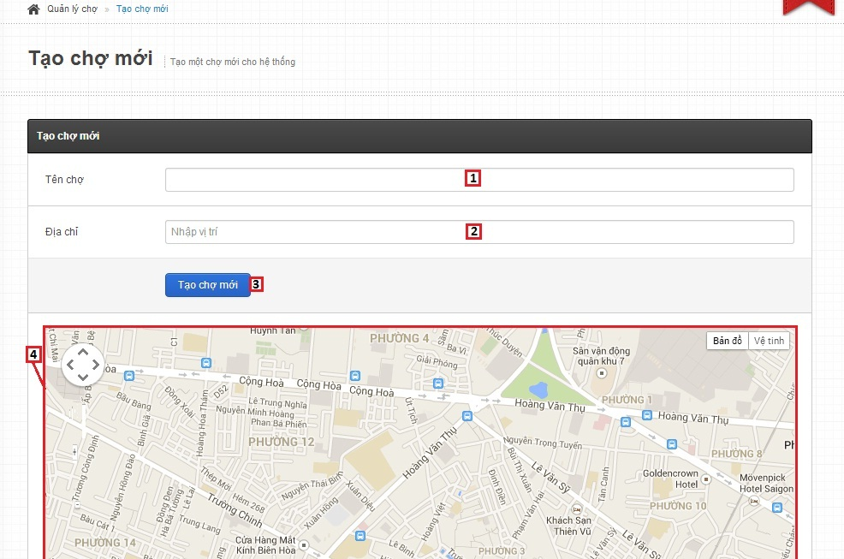

**Fields**

|  |  |  |  |  |  |  |  |
| --- | --- | --- | --- | --- | --- | --- | --- |
| **No** | **Field name** | **Description** | **Read only** | **Manda-tory** | **Control type** | **Data type** | **Length** |
| 1 | Market name | Fill market name | No | Yes | Textbox | String | N/A |
| 2 | Market address | Fill market address | No | Yes | Autocomplete Textbox | String | N/A |
| 4 | Maps | Show market address on maps | Yes | No | Google map | N/A | N/A |

**Button/Hyperlink**

|  |  |  |  |  |
| --- | --- | --- | --- | --- |
| **No** | **Function** | **Description** | **Validation** | **Outcome** |
| 3 | Create new market | Create new market | Yes | Transfer to manage market page |

* 1. **Staff – Manage parser**

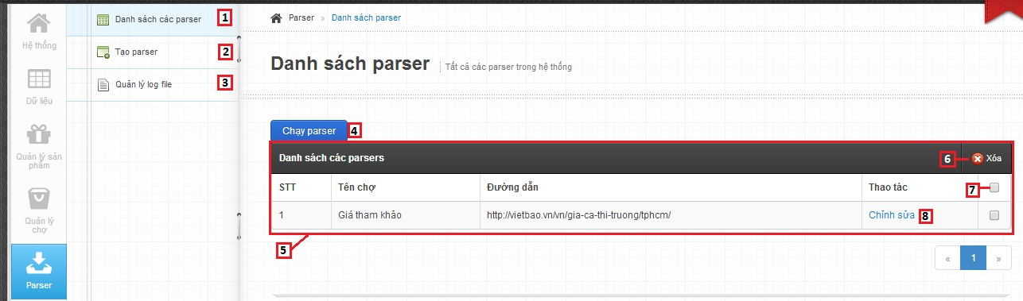

**Fields**

|  |  |  |  |  |  |  |  |
| --- | --- | --- | --- | --- | --- | --- | --- |
| **No** | **Field name** | **Description** | **Read only** | **Manda-tory** | **Control type** | **Data type** | **Length** |
| 5 | Parsers list | Table showing | Yes | Yes | Table | N/A | N/A |
| 7 | Select parser | Select parser to delete | No | No | Check box | N/A | N/A |

**Button/Hyperlink**

|  |  |  |  |  |
| --- | --- | --- | --- | --- |
| **No** | **Function** | **Description** | **Validation** | **Outcome** |
| 1 | Manage parsers | Click to go to manage parsers page | No | Transfer to manage parsers page |
| 2 | Create parser | Click to go to create parser page | No | Transfer to create parser page |
| 3 | Manage log file | Click to go to manage log file page | No | Transfer to log file page |
| 4 | Run parser | Click to run parser | No | Write log file |
| 6 | Delete parser | Click to delete the parser that selected | No | Message completed |
| 8 | Edit parser | Click to edit parser | No | Transfer to edit parser page |

**Table Markets List includes**

|  |  |  |  |  |  |
| --- | --- | --- | --- | --- | --- |
| **Field name** | **Description** | **Read only** | **Control type** | **Data type** | **Length** |
| No. | Number | Yes | Textview | Integer | N/A |
| Market name | Market name | Yes | Textview | String | N/A |
| Link | Link to parse | Yes | Textview | String | N/A |
| Action | Action of staff | No | Link, Checkbox | N/A | N/A |

* 1. **Staff – Create parser**
     1. **Create parser – Step 1**

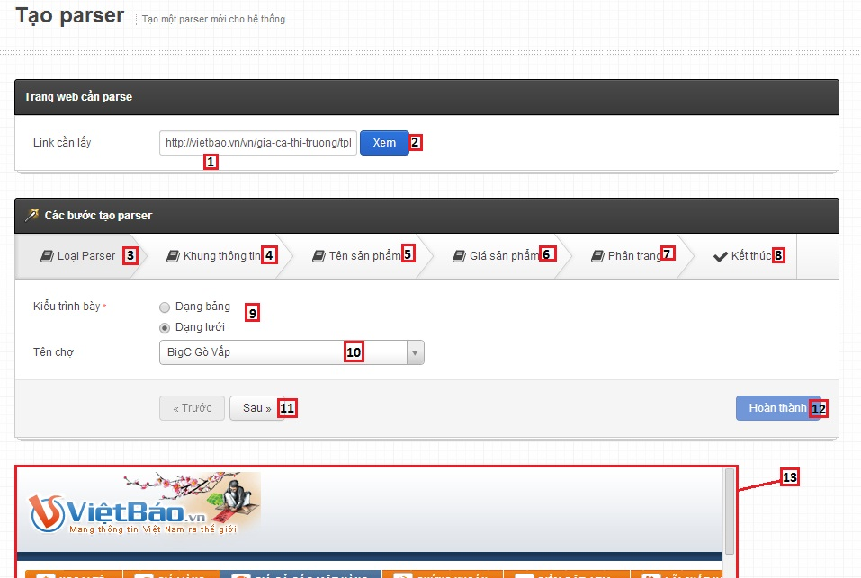

**Fields**

|  |  |  |  |  |  |  |  |
| --- | --- | --- | --- | --- | --- | --- | --- |
| **No** | **Field name** | **Description** | **Read only** | **Manda-tory** | **Control type** | **Data type** | **Length** |
| 1 | Link | Link to parse | No | Yes | Textbox | String | N/A |
| 9 | Type | Type View | No | Yes | Radio button | N/A | N/A |
| 10 | Market name | Market name | No | Yes | Drop down list | N/A | N/A |
| 11 | Web view | Web view | No | No | Web view | N/A | N/A |

**Button/Hyperlink**

|  |  |  |  |  |
| --- | --- | --- | --- | --- |
| **No** | **Function** | **Description** | **Validation** | **Outcome** |
| 2 | View web | View web from link | No | Display web view |
| 3 | Type of parser | Click to go to step 1 – type of parser | No | Transfer to step 1 |
| 4 | Tile xpath | Click to go to step 2 – Tile xpath | No | Transfer to step 2 |
| 5 | Product name xpath | Click to go to step 3 – Product name xpath | No | Transfer to step 3 |
| 6 | Product price xpath | Click to go to step 4 – Product price xpath | No | Transfer to manage parser page |
| 7 | Paging xPath | Click to go to step 5 – Paging xpath | No | Transfer to step 5 |
| 8 | Finish step | Click to go to step 6 – Finish parser | No | Transfer to step 6 |
| 11 | Next/Previous step | Next/Previous step | No | Transfer to next/previous step |
| 12 | Create parser | Click to create parser | Yes | Transfer to edit parser page |

* + 1. **Create parser – Step 2**

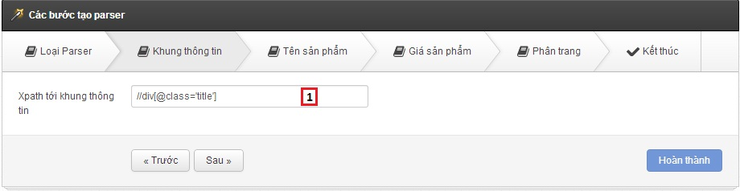

**Fields**

|  |  |  |  |  |  |  |  |
| --- | --- | --- | --- | --- | --- | --- | --- |
| **No** | **Field name** | **Description** | **Read only** | **Manda-tory** | **Control type** | **Data type** | **Length** |
| 1 | Tile xpath | Tile xpath | No | Yes | Textbox | String | N/A |

* + 1. **Create parser – Step 3**

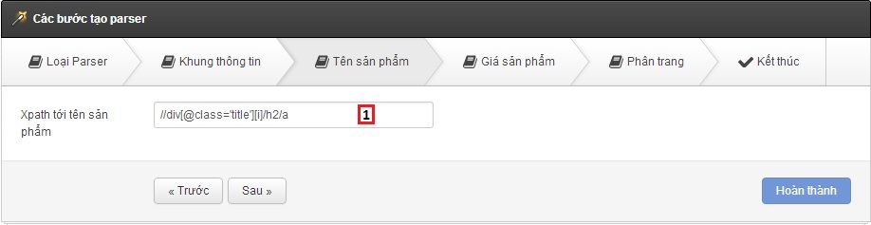

**Fields**

|  |  |  |  |  |  |  |  |
| --- | --- | --- | --- | --- | --- | --- | --- |
| **No** | **Field name** | **Description** | **Read only** | **Manda-tory** | **Control type** | **Data type** | **Length** |
| 1 | Product name xpath | Product name xpath | No | Yes | Textbox | String | N/A |

* + 1. **Create parser – Step 4**

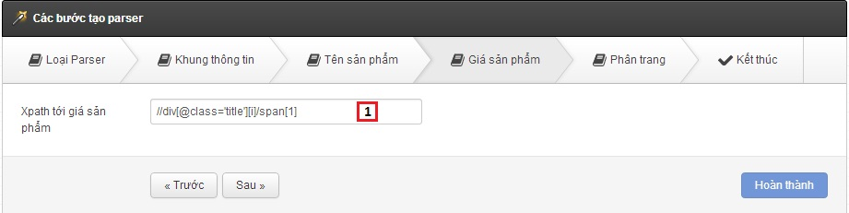

**Fields**

|  |  |  |  |  |  |  |  |
| --- | --- | --- | --- | --- | --- | --- | --- |
| **No** | **Field name** | **Description** | **Read only** | **Manda-tory** | **Control type** | **Data type** | **Length** |
| 1 | Product price xpath | Product price xpath | No | Yes | Textbox | String | N/A |

* + 1. **Create parser – Step 5**

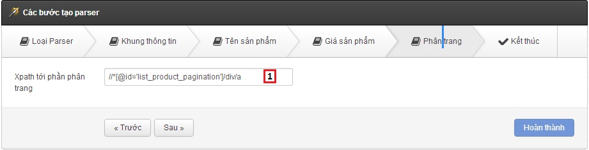

**Fields**

|  |  |  |  |  |  |  |  |
| --- | --- | --- | --- | --- | --- | --- | --- |
| **No** | **Field name** | **Description** | **Read only** | **Manda-tory** | **Control type** | **Data type** | **Length** |
| 1 | Paging xpath | Paging xpath | No | Yes | Textbox | String | N/A |

* + 1. **Create parser – Step 6**

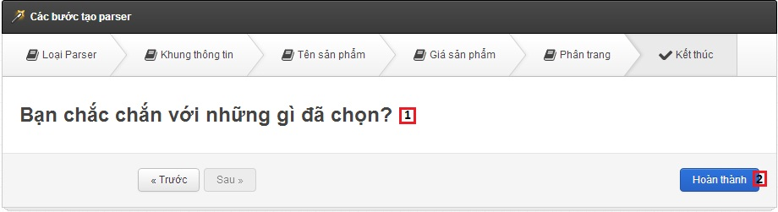

**Fields**

|  |  |  |  |  |  |  |  |
| --- | --- | --- | --- | --- | --- | --- | --- |
| **No** | **Field name** | **Description** | **Read only** | **Manda-tory** | **Control type** | **Data type** | **Length** |
| 1 | Message confirm | Message confirm | Yes | Yes | Textview | String | N/A |

**Button/Hyperlink**

|  |  |  |  |  |
| --- | --- | --- | --- | --- |
| **No** | **Function** | **Description** | **Validation** | **Outcome** |
| 2 | Create parser | Click to create parser | Yes | Transfer to edit parser page |

* 1. **Staff – Manage log file**

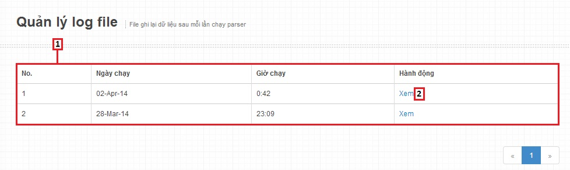

**Fields**

|  |  |  |  |  |  |  |  |
| --- | --- | --- | --- | --- | --- | --- | --- |
| **No** | **Field name** | **Description** | **Read only** | **Manda-tory** | **Control type** | **Data type** | **Length** |
| 1 | Log file list | Table showing | Yes | Yes | Table | N/A | N/A |

**Button/Hyperlink**

|  |  |  |  |  |
| --- | --- | --- | --- | --- |
| **No** | **Function** | **Description** | **Validation** | **Outcome** |
| 1 | View log file | Click to view log file | No | Transfer to log file detail |

**Table Log file List includes**

|  |  |  |  |  |  |
| --- | --- | --- | --- | --- | --- |
| **Field name** | **Description** | **Read only** | **Control type** | **Data type** | **Length** |
| No. | Number | Yes | Textview | Integer | N/A |
| Date start | Date start | Yes | Textview | String | N/A |
| Time start | Time start | Yes | Textview | String | N/A |
| Action | Action of staff | No | Link | N/A | N/A |

1. **Mobile Interface Design**
   1. **Mobile – Login screen**



**Fields**

|  |  |  |  |  |  |  |  |
| --- | --- | --- | --- | --- | --- | --- | --- |
| **No** | **Field Name** | **Description** | **Read only** | **Mandatory** | **Control Type** | **Data Type** | **Length** |
| 1 | Username | Fill account name | No | Yes | Textbox | String | N/A |
| 2 | Password | Fill password | No | Yes | Password | String | N/A |

**Button/ Hyperlink**

|  |  |  |  |  |
| --- | --- | --- | --- | --- |
| **No** | **Function** | **Description** | **Validation** | **Outcome** |
| 3 | Login | Log-in into the system | N/A | Transfer to Favorite product screen |

* 1. **Mobile – Favorite product screen**

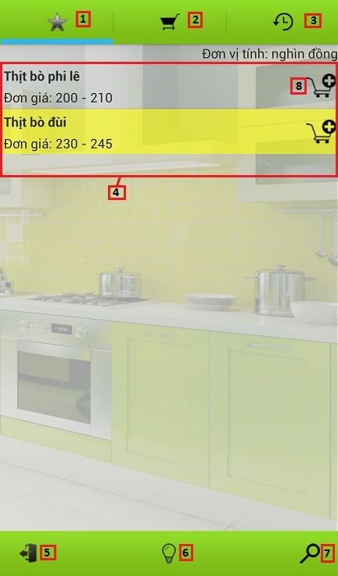

**Fields**

|  |  |  |  |  |  |  |  |
| --- | --- | --- | --- | --- | --- | --- | --- |
| **No** | **Field Name** | **Description** | **Read only** | **Mandatory** | **Control Type** | **Data Type** | **Length** |
| 4 | Favorite product list | Table showing | Yes | Yes | Table | N/A | N/A |

**Button/ Hyperlink**

|  |  |  |  |  |
| --- | --- | --- | --- | --- |
| **No** | **Function** | **Description** | **Validation** | **Outcome** |
| 1 | Favorite product | Click to go to Favorite product screen | N/A | Transfer to Favorite product screen |
| 2 | View cart | Click to go to View cart screen | N/A | Transfer to View cart screen |
| 3 | History | Click to go to History screen | N/A | Transfer to History screen |
| 5 | Log out | Click to logout account | N/A | Transfer to Login screen |
| 6 | Suggest route | Click to go to Suggest route screen | N/A | Transfer to Suggest route screen |
| 7 | Search product | Click to go to Search product screen | N/A | Transfer to Search product screen |
| 8 | Add product to cart | Click to add product to cart | N/A | N/A |

**Table Favorite product List includes**

|  |  |  |  |  |  |
| --- | --- | --- | --- | --- | --- |
| **Field name** | **Description** | **Read only** | **Control type** | **Data type** | **Length** |
| Product name | Product name | Yes | Textview | String | N/A |
| Product price | Product price | Yes | Textview | Integer | N/A |

* 1. **Mobile – View cart screen**

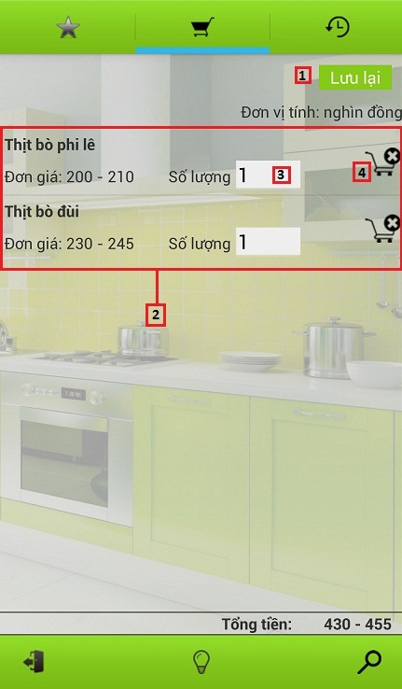

**Fields**

|  |  |  |  |  |  |  |  |
| --- | --- | --- | --- | --- | --- | --- | --- |
| **No** | **Field Name** | **Description** | **Read only** | **Mandatory** | **Control Type** | **Data Type** | **Length** |
| 2 | Cart items list | Table showing | Yes | Yes | Table | N/A | N/A |
| 3 | Quantity of product | Fill product quantity | No | N/A | Textbox | Integer | [1-10] |

**Button/ Hyperlink**

|  |  |  |  |  |
| --- | --- | --- | --- | --- |
| **No** | **Function** | **Description** | **Validation** | **Outcome** |
| 1 | Save cart | Click to save cart to history | N/A | Transfer to History screen |
| 4 | Remove item in cart | Click to remove product in cart | N/A | N/A |

**Table Cart items List includes**

|  |  |  |  |  |  |
| --- | --- | --- | --- | --- | --- |
| **Field name** | **Description** | **Read only** | **Control type** | **Data type** | **Length** |
| Product name | Product name | Yes | Textview | String | N/A |
| Product price | Product price | Yes | Textview | Integer | N/A |

* 1. **Mobile – History screen**

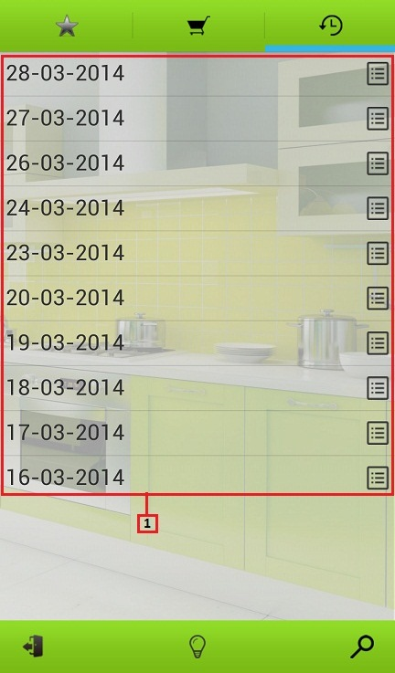

**Fields**

|  |  |  |  |  |  |  |  |
| --- | --- | --- | --- | --- | --- | --- | --- |
| **No** | **Field Name** | **Description** | **Read only** | **Mandatory** | **Control Type** | **Data Type** | **Length** |
| 1 | Histories list | Table showing | Yes | Yes | Table | N/A | N/A |

**Table Histories List includes**

|  |  |  |  |  |  |
| --- | --- | --- | --- | --- | --- |
| **Field name** | **Description** | **Read only** | **Control type** | **Data type** | **Length** |
| Date | Date save cart | Yes | Textview | String | N/A |

* 1. **Mobile – History detail screen**

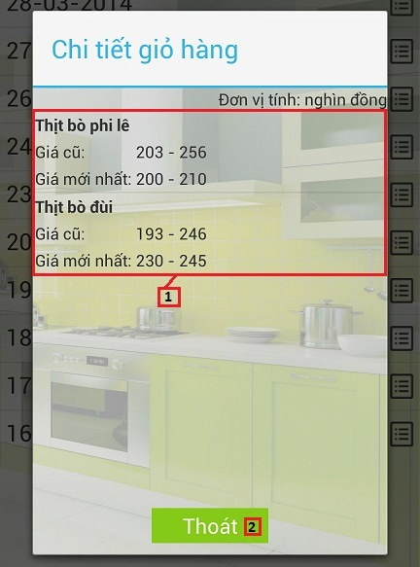

**Fields**

|  |  |  |  |  |  |  |  |
| --- | --- | --- | --- | --- | --- | --- | --- |
| **No** | **Field Name** | **Description** | **Read only** | **Mandatory** | **Control Type** | **Data Type** | **Length** |
| 1 | History details list | Table showing | Yes | Yes | Table | N/A | N/A |

**Button/ Hyperlink**

|  |  |  |  |  |
| --- | --- | --- | --- | --- |
| **No** | **Function** | **Description** | **Validation** | **Outcome** |
| 2 | Cancel | Click to history detail close pop-up | N/A | Close history detail pop-up |

**Table History details List includes**

|  |  |  |  |  |  |
| --- | --- | --- | --- | --- | --- |
| **Field name** | **Description** | **Read only** | **Control type** | **Data type** | **Length** |
| Product name | Product name | Yes | Textview | String | N/A |
| Old price | Old product price | Yes | Textview | Integer | N/A |
| New price | New product price | Yes | Textview | Integer | N/A |

* 1. **Mobile – Search product screen**

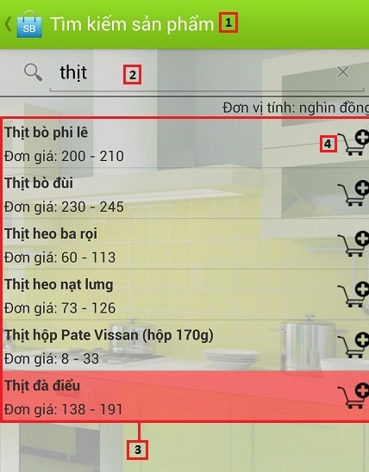

**Fields**

|  |  |  |  |  |  |  |  |
| --- | --- | --- | --- | --- | --- | --- | --- |
| **No** | **Field Name** | **Description** | **Read only** | **Mandatory** | **Control Type** | **Data Type** | **Length** |
| 2 | Search text box | Fill key to search product | No | No | Textbox | String | N/A |
| 3 | Search result list | Table showing | Yes | Yes | Table | N/A | N/A |

**Button/ Hyperlink**

|  |  |  |  |  |
| --- | --- | --- | --- | --- |
| **No** | **Function** | **Description** | **Validation** | **Outcome** |
| 1 | Back | Back to cart view screen | N/A | Transfer to Cart view screen |
| 4 | Add product to cart | Click to add product to cart | N/A | N/A |

**Table Search result List includes**

|  |  |  |  |  |  |
| --- | --- | --- | --- | --- | --- |
| **Field name** | **Description** | **Read only** | **Control type** | **Data type** | **Length** |
| Product name | Product name | Yes | Textview | String | N/A |
| Product price | Product price | Yes | Textview | Integer | N/A |

* 1. **Mobile – Propose product price**

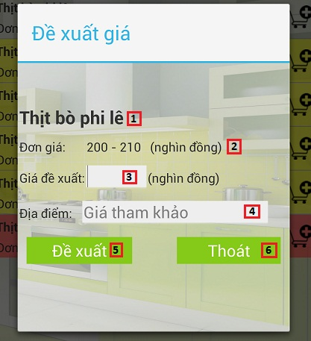

**Fields**

|  |  |  |  |  |  |  |  |
| --- | --- | --- | --- | --- | --- | --- | --- |
| **No** | **Field Name** | **Description** | **Read only** | **Mandatory** | **Control Type** | **Data Type** | **Length** |
| 1 | Product name | Product name | Yes | Yes | Textview | String | N/A |
| 2 | Product price | Product price | Yes | Yes | Textview | Integer | N/A |
| 3 | Propose product price | Fill propose product price | No | Yes | Textbox | Integer | [1-10000] |
| 4 | Market name | Fill market name | No | Yes | Autocomplete textbox | String | N/A |

**Button/ Hyperlink**

|  |  |  |  |  |
| --- | --- | --- | --- | --- |
| **No** | **Function** | **Description** | **Validation** | **Outcome** |
| 5 | Propose price | Click to propose price | Yes | Show success message pop-up |
| 6 | Cancel | Click to close propose product price pop-up | No | Close propose product price pop-up |

* 1. **Mobile – Suggest route screen**

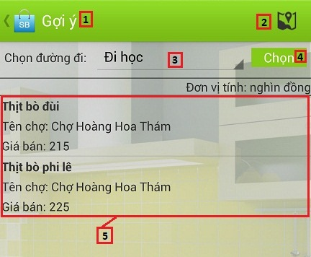

**Fields**

|  |  |  |  |  |  |  |  |
| --- | --- | --- | --- | --- | --- | --- | --- |
| **No** | **Field Name** | **Description** | **Read only** | **Mandatory** | **Control Type** | **Data Type** | **Length** |
| 3 | Route | Route name | No | No | Drop down list | N/A | N/A |
| 5 | Order details list | Table showing | Yes | Yes | Table | N/A | N/A |

**Button/ Hyperlink**

|  |  |  |  |  |
| --- | --- | --- | --- | --- |
| **No** | **Function** | **Description** | **Validation** | **Outcome** |
| 1 | Back | Back to cart view screen | N/A | Transfer to Cart view screen |
| 2 | Maps | Click to go to maps screen | N/A | Transfer to Maps screen |
| 4 | Suggest route | Click to view table order details list | N/A | Show table order details list |

**Table Order details List includes**

|  |  |  |  |  |  |
| --- | --- | --- | --- | --- | --- |
| **Field name** | **Description** | **Read only** | **Control type** | **Data type** | **Length** |
| Product name | Product name | Yes | Textview | String | N/A |
| Market name | Market name | Yes | Textview | String | N/A |
| Product price | Product price | Yes | Textview | Integer | N/A |

* 1. **Mobile – Maps screen**

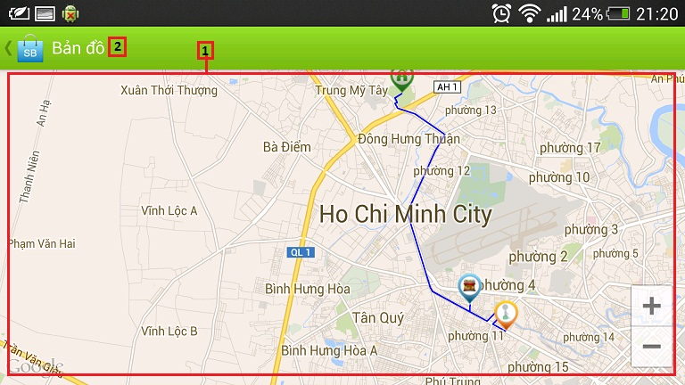

**Fields**

|  |  |  |  |  |  |  |  |
| --- | --- | --- | --- | --- | --- | --- | --- |
| **No** | **Field Name** | **Description** | **Read only** | **Mandatory** | **Control Type** | **Data Type** | **Length** |
| 1 | Maps | Show maps suggest | Yes | Yes | Google map | N/A | N/A |

**Button/ Hyperlink**

|  |  |  |  |  |
| --- | --- | --- | --- | --- |
| **No** | **Function** | **Description** | **Validation** | **Outcome** |
| 2 | Back | Back to Suggest route screen | N/A | Transfer to Suggest route screen |